Antivirus Scanner

🛡️ What Is the Antivirus Scanner Component in a Mail Server System?
# Source: AI Source: Provided by: [Data Path: Persons Table -> ID Column: 1, Name_En Column: Motasem Essam] -> From: [Chatgpt (GPT‑5 Mini)] on [1/21/2026]
The Antivirus Scanner Component is responsible for detecting and blocking malicious attachments or email content (such as viruses, worms, ransomware, and trojans) before they reach the recipient's inbox.
It acts as an email firewall, scanning all incoming and sometimes outgoing messages to protect both the server and users.

🧠 Why It's Important
# Source: AI Source: Provided by: [Data Path: Persons Table -> ID Column: 1, Name_En Column: Motasem Essam] -> From: [Chatgpt (GPT‑5 Mini)] on [1/21/2026]
- Emails are a common delivery method for malware.
- Attachments or links can infect the recipient's device.
- A virus-infected email server can become blacklisted or compromise an organization.
- It ensures compliance with security policies and best practices.

⚙️ How It Works
# Source: AI Source: Provided by: [Data Path: Persons Table -> ID Column: 1, Name_En Column: Motasem Essam] -> From: [Chatgpt (GPT‑5 Mini)] on [1/21/2026]
The antivirus component scans:
- 📎 Attachments (e.g., .exe, .docm, .zip)
- 🔗 Links in the email body
- 🧬 Email content for known signatures
- 🐛 Behavior patterns (heuristics for zero-day threats)
When a threat is detected:
- The email is rejected, quarantined, or flagged for review.

🔁 Where It Sits in the Mail Flow
# Source: AI Source: Provided by: [Data Path: Persons Table -> ID Column: 1, Name_En Column: Motasem Essam] -> From: [Chatgpt (GPT‑5 Mini)] on [1/21/2026]
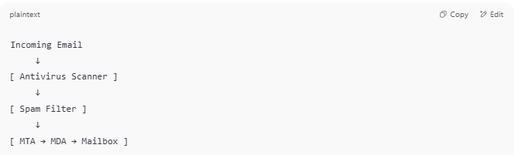

Incoming Email
↓
[ Antivirus Scanner ]
↓
[ Spam Filter ]
↓
[ MTA → MDA → Mailbox ]

Sometimes antivirus is combined with the spam filter.

🧰 Common Antivirus Tools for Email Servers
# Source: AI Source: Provided by: [Data Path: Persons Table -> ID Column: 1, Name_En Column: Motasem Essam] -> From: [Chatgpt (GPT‑5 Mini)] on [1/21/2026]
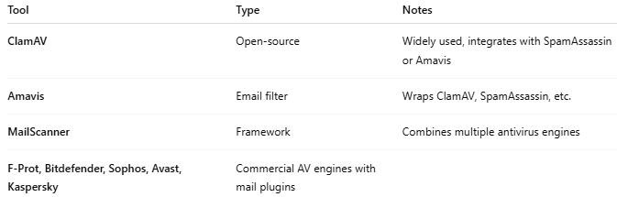

Tool | Type | Notes
ClamAV | Open-source | Widely used, integrates with SpamAssassin or Amavis
Amavis | Email filter | Wraps ClamAV, SpamAssassin, etc.
MailScanner | Framework | Combines multiple antivirus engines
F-Prot, Bitdefender, Sophos, Avast, Kaspersky | Commercial AV engines with mail plugins

📊 Antivirus Scanner vs. Spam Filter
# Source: AI Source: Provided by: [Data Path: Persons Table -> ID Column: 1, Name_En Column: Motasem Essam] -> From: [Chatgpt (GPT‑5 Mini)] on [1/21/2026]
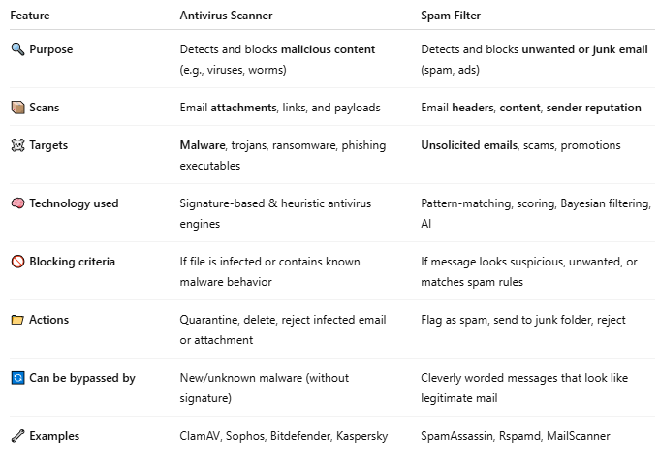

Feature | Antivirus Scanner | Spam Filter
🔍 Purpose | Detects and blocks malicious content (e.g., viruses, worms) | Detects and blocks unwanted or junk email (spam, ads)
📦 Scans | Email attachments, links, and payloads | Email headers, content, sender reputation
☠️ Targets | Malware, trojans, ransomware, phishing executables | Unsolicited emails, scams, promotions
🧠 Technology used | Signature-based & heuristic antivirus engines | Pattern-matching, scoring, Bayesian filtering, AI
🚫 Blocking criteria | If file is infected or contains known malware behavior | If message looks suspicious, unwanted, or matches spam rules
📁 Actions | Quarantine, delete, reject infected email or attachment | Flag as spam, send to junk folder, reject
🔄 Can be bypassed by | New/unknown malware (without signature) | Cleverly worded messages that look like legitimate mail
🔧 Examples | ClamAV, Sophos, Bitdefender, Kaspersky | SpamAssassin, Rspamd, MailScanner

🧠 Example Scenarios
# Source: AI Source: Provided by: [Data Path: Persons Table -> ID Column: 1, Name_En Column: Motasem Essam] -> From: [Chatgpt (GPT‑5 Mini)] on [1/21/2026]

- 📬 Spam Filter in action:
You get an email with the subject "You won $1,000,000!" — the spam filter checks it, sees it’s from a suspicious domain, and moves it to Junk.
- 🛡️ Antivirus Scanner in action:
You get an email with an attachment invoice.exe — the antivirus scans the file and finds malware, so the mail is blocked or quarantined.

🔁 Used Together
# Source: AI Source: Provided by: [Data Path: Persons Table -> ID Column: 1, Name_En Column: Motasem Essam] -> From: [Chatgpt (GPT‑5 Mini)] on [1/21/2026]
In a real mail server setup, both are used in sequence:
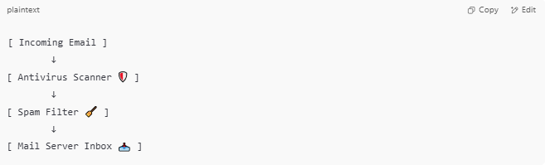
[ Incoming Email ]
↓
[ Antivirus Scanner 🛡️ ]
↓
[ Spam Filter 🧹 ]
↓
[ Mail Server Inbox 📥 ]

✅ Summary
# Source: AI Source: Provided by: [Data Path: Persons Table -> ID Column: 1, Name_En Column: Motasem Essam] -> From: [Chatgpt (GPT‑5 Mini)] on [1/21/2026]
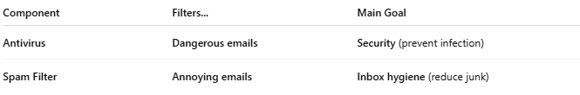

Component | Filters... | Main Goal
Antivirus | Dangerous emails | Security (prevent infection)
Spam Filter | Annoying emails | Inbox hygiene (reduce junk)

✅ Summary
# Source: AI Source: Provided by: [Data Path: Persons Table -> ID Column: 1, Name_En Column: Motasem Essam] -> From: [Chatgpt (GPT‑5 Mini)] on [1/21/2026]
The Antivirus Scanner Component ensures that all email traffic is free of malware and viruses, safeguarding both the mail server and the recipients from infection.

